

Data Visualisations

Cost of Living in the United States of America vs Australia

TRAN DUC ANH DANG | 103995439

Word Count: 2232

# Executive Summary

This report uses data from Numbeo and the Federal Reserve Bank of St. Louis to investigate the cost of living in the United States and Australia, aiming to provide readers with an easy to understand visualisation of financial status and wellbeing in both countries. Choropleth maps and bar charts are used to display cost of living indices and compare the Consumer Price Index (CPI) of both nations. Results show that Australia has a higher overall cost of living index and significantly higher inflation rates in recent years.

The data may not accurately reflect individual cost of living experiences due to factors such as lifestyle and spending habits. The report acknowledges limitations in the visuals and data sources used, suggesting areas for improvement. In conclusion, the report offers a basic understanding of the differences in cost of living between the United States and Australia, serving as a resource for readers considering where to live and work. Choropleth maps and bar charts offer valuable insights but may not fully represent individual cost of living experiences.

Table of Contents

Executive Summary 1

Introduction 3

Visualisation: 4

Cost of Living Index: 4

Analysis on the Cost of Living using Choropleth map: 5

Consumer Price Index (CPI): 5

Analysis on Consumer Price Index via Bar Chart: 6

Conclusions: 7

References: 7

# Introduction

The cost of living of living in a country is depending on many factor such as financial stability, and overall wellbeing of individuals and families. This is referring to the expenses and a standard living such as housing, transportation, food, healthcare, education and other goods and services.

The cost of living in the USA and Australia are depending on several factors such as location, living lifestyle, and other expense. As the United States and Australia are considered as nations with high standards of livings therefore it is corresponding with a higher cost of living than other countries. According to World Population Review, Australia is amongst the top 10 most expensive countries to live in, ranking 7 with a cost of living index at 75.32. On the other hand, the United States is in top 20 ranking at the 16 with a cost of living index at 72.38.

The purpose of this report is to compare the cost of living between the US and Australia using heatmap (Choropleth map) of cost of living in different cities and regions and the bar chart that comparing the Consumer Price Index (CPI) are the methods that can provide valuable insights into differences between two countries.

This aims for this report is to provide a visuals when comparing the cost of living between the United States and Australia, where major factors that impact the cost of living in both countries by using two different comparison method, choropleth of the cost of living and bar chart to comparing the Consumer Price Index (CPI).

This report will also serve as a valuable resource for individuals, families, students and professionals when making decisions about where to live and work, and also help them to visualising how the cost of living impact on their daily lives.

# Visualisation:

## Cost of Living Index:

|  |  |
| --- | --- |
| United States of America | Australia |
|  |  |
|  |  |

*Source****: https://www.numbeo.com/*** *| Numbeo - Cost of Living*

#### Choropleth Map in Represent Cost of Living Index

This chart above is known as choropleth map or can also be known as heat map, that uses different shades or colours to represent data values in different countries or cities in United States and Australia. From the table above, the second row currently displays the cost of living in different cities within both countries while the third row displaying the cost of living index in both countries. The data is representing the measured value of numerical data using a colour scale from many cost of living indices to represent the relative cost of living in each location, where a darker shades (red) representing the higher cost of living indices while lighter shades (green) representing lower indices. *"Cost of living is a measurement based on the amount that individuals need to cover daily expenses" (The Balance Money)*, and can be calculate in many way, the most widely accepted cost of living measure is the Consumer Price Index (CPI) which will be including in this report.

#### Choropleth Map Advantages, Disadvantages, Improvement in Represents Cost of Living Index

The choropleth map has its own advantages and disadvantages. It allows users to easily compare the cost of living across different areas, however the colour scale appears to be very easy to visualize but in real life it may be challenging as it is limiting its accessibility. Furthermore, the map is lacks detailed information about what factor that explained of how the cost of living index is calculated in each location, making it difficult for the readers to understand the reasons behind the differences in cost of living. Not only that, but the data also represents the cost of living index taken from Numbeo's may not be 100% accurate as it is taken by the user's inputs.

When taking a high cost of living factor in account, it can also impact country's quality life in many ways. Therefore, there might be some improving that could been done to displays factors that contribute the cost of living in different countries or cities within the United States and Australia by providing more detail information about the factors that contributing to the cost of living in each locations by adding an information table that allows users to hover over each region to have more access to information such as the value of average wage, transportation, rent, housing market, etc. Not only that, as stated above, Numbeo's might not be the most reliable sources, therefore, to improving the accuracy of the cost of living data, it is best to consider some incorporating information from many different sources, such as government data or other reputable organisation alongside with the data from Numbeo.

### Analysis on the Cost of Living using Choropleth map:

When looking at the cost of living in two different countries by using choropleth map, in this case, the United States and Australia. It becomes clearer that Australia has a higher overall cost of living than the United States. The cost of living index in Australia is almost 4% higher than that of the United States.

When looking and compare the living expenses in different cities across the United States and Australia, Santa Barbara has been at the tops list in the US, compare to its competitor, Brisbane is the highest cost of living in Australia. Santa Barbara with its cost of living index up to 112.2, it is significantly higher than Brisbane that only comes up to 82.5. This means there's a 29.7 points difference or close to 31% difference between the two highest cost of living cities.

The cost of living measured on average cost of living indices may not be accurately in reflecting individual actual cost of living in each city or country when there are many other factors could contribute in this such as living lifestyle, housing, food, and other expense. However, the data presented in Choropleth map has been a useful starting point for understanding the differences in the cost of living between each cities or within the United States and Australia.

## Consumer Price Index (CPI):

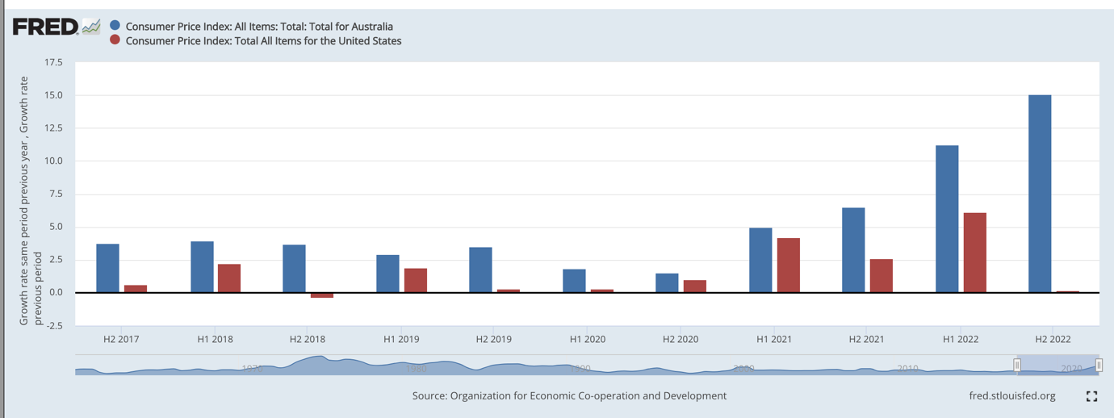

*Source:* ***https://fred.stlouisfed.org/*** *| Federal Reserve Bank of St. Louis*

#### Bar Chart in Represent Consumer Price Index

The bar chart above will compare the semi-annual that summed Consumer Price Index (CPI) of the United States and Australia, where it will all of the main factors that contribute to the cost of living, such as housing, transportation, food, healthcare, and other expense. The CPI is an indicator that measures the rate of inflation, which is the greatest threat to a healthy economy. The data that has been sourced from Federal Reserve Economic Data (FRED) showing that in the last 5 years, the inflation rate in Australia has been increasing and significantly increasing in the last 2-3 years.

#### Bar Chart Advantages, Disadvantages, Improvement in Represent Consumer Price Index

The bar chart that displaying the comparison between the CPI of the United States and Australia has its own advantages and disadvantages. It allows users to easily understand as it is simple and familiar to both people, making it easy for them to comparing the CPI between both countries. However, bar chart only suitable for simple comparisons, and they might not be the best choice to find the relationships or trends in data when it is getting more complex. This could solve and improve when changing to other chart types such as line charts, as it more appropriate to displaying the changes of data over time

Even though there is limitation when using bar chart in this comparison, but it is the most appropriate to allows the readers easily to read the data across the United States and Australia. However, if there is an increase in its complexity, the recommendation chart type is line chart is a better suitable choice but for now bar charts has offer a simple and effective way to compare the CPI between the United States and Australia.

### Analysis on Consumer Price Index via Bar Chart:

When looking at the Consumer Price Index (CPI) of the United States and Australia using bar chart. The result that observes was a surprise that the inflation rate in Australia in the last 5 years always higher than the United States, and it is significantly higher in the period of 2021 and 2022 even though there is a chance of the data in H2 2022 CPI for the United States might be incorrect.

When comparing the CPI using bar chart, it has provided a clear and effective way to comparing the total summed CPI values of the United States and Australia in the last 5 years, and allowing the readers to gain an insights view into the cost of living in both countries. When looking at the chart, there is a difference that can be point out right away that Australia in the last 5 years the inflation rate has never been drop and keep increasing compared to the United States. It has shown that the cost of living in Australia a typically higher and significantly higher than United States recently. However, as stated in **'Comparison Cost of Living via Choropleth map',** it is not fully reflecting individual actual cost of living as it is depending on their living lifestyle and spending habits.

Overall, when coming to comparing the CPI of both countries using bar chart, it reveals to the readers that Australian has been living at a higher cost in the last 5 years comparing to the United States and it is significantly higher recently. However, as stated many times, it is also important that the CPI values may not provide an reflect on the actual cost of living for each individuals are depending on many factors that could play an impact on these values.

# Conclusions:

In conclusions, when combing both data of the United States and Australia from Cost of Living Index using choropleth map and the Consumer Price Index (CPI) using bar chart. It is suggested that in the recent years, Australia inflation rate and cost of living is significantly higher than the United States. However, these values are not always 100% accurate as it hasn't been able to reflect the actual cost of living for each individuals. Furthermore, choropleth map provides a useful starting point for understanding the differences between the two countries but it still lacks information on other factors that also contribute to the cost of living in each regions. On the other hand, bar chart is simple and easy to understand while also a good choice to pick when comparing the CPI values in the last 5 years between two countries, but it still may not a good choice to pick if the data is gotten more complex, for examples 20, 30, 40 years. Overall, both has been providing a basic understanding to the readers on the differences in cost of living between the United States and Australia.

# References:

World Population Review. (n.d.). Most Expensive Countries To Live In. Retrieved from <https://worldpopulationreview.com/country-rankings/most-expensive-countries-to-live-in>

Investopedia. (2021). Cost of Living. Retrieved from <https://www.investopedia.com/terms/c/cost-of-living.asp>

Geo Wilmington. (n.d.). Choropleth Maps Pros & Cons. Retrieved from <http://geowilmington.weebly.com/uploads/2/3/5/2/23528728/choropleth_maps_pros___cons.pdf>

Missouri Economic Research and Information Center. (n.d.). Cost of Living Data Series. Retrieved from <https://meric.mo.gov/data/cost-living-data-series>

Numbeo. (2023). Cost of Living Index by Country 2023. Retrieved from <https://www.numbeo.com/cost-of-living/region_rankings.jsp?title=2023&region=009&displayColumn=0>

Numbeo. (2023). Cost of Living Index by Country 2023. Retrieved from <https://www.numbeo.com/cost-of-living/region_rankings.jsp?title=2023&region=021>

Geography Point. (2022). 4 Advantages and 5 Disadvantages of a Chloropleth Map. Retrieved from <https://geographypoint.com/2022/08/4-advantages-and-5-disadvantages-of-a-chloropleth-map/>

Investopedia. (2021). Consumer Price Index (CPI). Retrieved from <https://www.investopedia.com/terms/c/consumerpriceindex.asp>

The Balance Money. (n.d.). Consumer Price Index (CPI) Index Definition and Calculation. Retrieved from <https://www.thebalancemoney.com/consumer-price-index-cpi-index-definition-and-calculation-3305735>

The Balance Money. (n.d.). What Is Cost of Living? Retrieved from <https://www.thebalancemoney.com/what-is-cost-of-living-5101122>

Tech Quintal. (n.d.). Advantages and Disadvantages of Bar Diagram. Retrieved from <https://www.techquintal.com/advantages-and-disadvantages-of-bar-diagram/>